Project Number 3
Green Belt Establishment and Afforestation Development in
Thi-qar province of Iraq

Introduction

The world is facing with the challenge of climate change. Water shortages and desertification are major outcomes of this challenge.In addition towidespread poverty, the most obvious impact of desertification is degradation of over 3.3 billion hectares of the world's rangelands and pastures which have a great capacity for human living and food production.
Due to being located in arid and semi-arid belt of word, countries like Iraq and Iran are a low forest cover region of the world. Islamic Republic of Iran is one of the world’s leading countries in combating desertification: In this connection, more than two million hectares of forest planting and five million hectares of desert combatingprojects has implemented in recent decades which due to high degree of ecological similarity could act as excellent pattern for afforestation and green belt establishment in Thi-qar Province.
Green belt and afforestation objectives
According to multi-functional nature of green spaces (to serve as wild habitat, wind break, sand dune fixation, forest park and recreational affairs, green shelter belt around urban regions and agricultural production likes food, feed and wood) it is very necessary to determine and work based on the main objective of greenery development in the target region or regions. It is very important for selecting the most suitable tree or shrub species in region. In arid and semi-arid zones of Iran, planting following species were tested successfully: Tamarixarticulate, Prosopisspicegera, Parkinsoniaaculeata,a. spinachristi, albiziajulibrissi, Eucalyptus camaldulensis, Atriplexcanescensand so on Fig 1, 2 and 3.

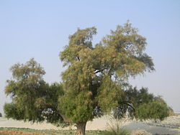
Fig. 1, Tamarixarticulate, afforestation, Albaji region, Ahwaz, Khouzestan, Iran
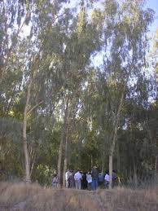
Fig. 2, Eucalyptus camaldulensis, afforestation, fassa, Fars province, southern Iran
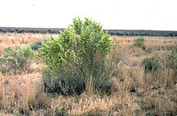
Fig. 3, Atriplexcanescens, a species of evergreenshrub
Due to scarcity of water resources in the region, at first hydrological information of Thi-qar should be determined clearly for realizing water availability amounts and current and expected major users of water resources and also their contribution. According to officials expected water amount and sharing ratio among sub projects or what we can determine optimum sharing ratio thorough a multi objective programming approach, among sub projects.
Based on expected amount of area is necessary to be afforested, water allotted, fruit bearing or not fruit bearing trees and so on, the most tolerate species with an emphasis on indigoes species will be chosen and planted. Appropriate geometry, population per dunam and optimum irrigation systems will be based on species choosing and detailed objectives of project. Successful performed similar projects in Iran and especially in Khouzestan province could be a useful experience in this area. Green belt area could serve also as a habitat for dangerous animals like snakes and keep them away from residential areas.
The aim of this study is investigationthe prerequisite conditions and the feasibility analysis according to ecological, technical and social parameters affecting on successfulness of green belt development, water resources, water consumption, and Factors related to the detailed -research objectives.

- Soil and water
- Identifying soil characteristics such as texture, structure, caco3, ph, soil EC, soil salinity, penetration resistance and permeability
- Irrigated water EC, PH, water demand, water saving measures
- Ecology and Climate
- Determining Elevation, longitude, latitude of target regions
- Investigation of average annual temperature, average minimum temperature, number of frost days, minimum temperature in previous 10 years
- Measuring Arid biological coefficient, annual Precipitation and its time distribution
- Determining the climate category of region
- Trees and shrub species
- Choosing the best tolerate and suitable species
- Studying the Appropriate geometry, population per dunam and optimum irrigation systems and regimes
- Integrating different chemical and biological mulch and afforestation
- Investigating the effects of irrigation methods on survival and growth rate
- Determining the best irrigation intervals
- Tree seedling production feasibility analysis
- Investigating efficient measures for reducing evaporation and saving more water
- Identifying People participation in sustainable afforestation
- Studying the behavior of people in relation to green belt establishment and enhancing their participation
- Gathering and analyzing data about the green cover plants amount needed
- Investigate the green belt area and plant diversity for each region and climate
- Preparing the map of soil related to type of trees for planting
- Preparing the final zero phase with all costs for each area

